Mentorship app/ system
You can register as a mentor/ mentee.
Registration details:-
- Full name, Contact Number, Position (all auto populated by office information)
- Work experience, University/ college , Highest/ Current Qualifications
- What I expect from my mentee, reason I would like to be a mentor, professional profile , Linked in profile link( can open it there )
Once registered for both roles the buttons will say load as mentee / load as mentor which will take you to their dasboards
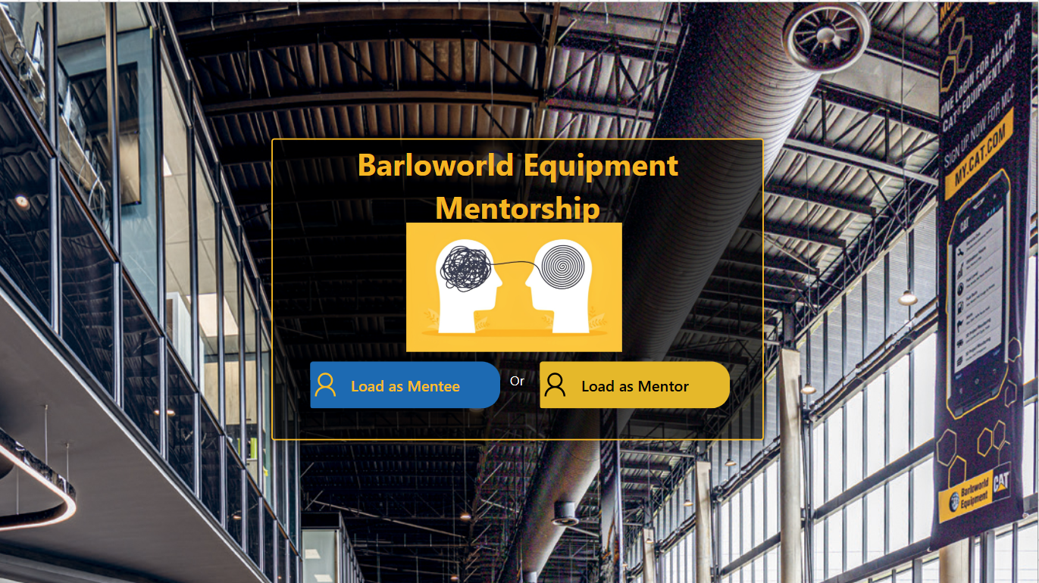

Mentee dashboard
It will have a loader/ gif
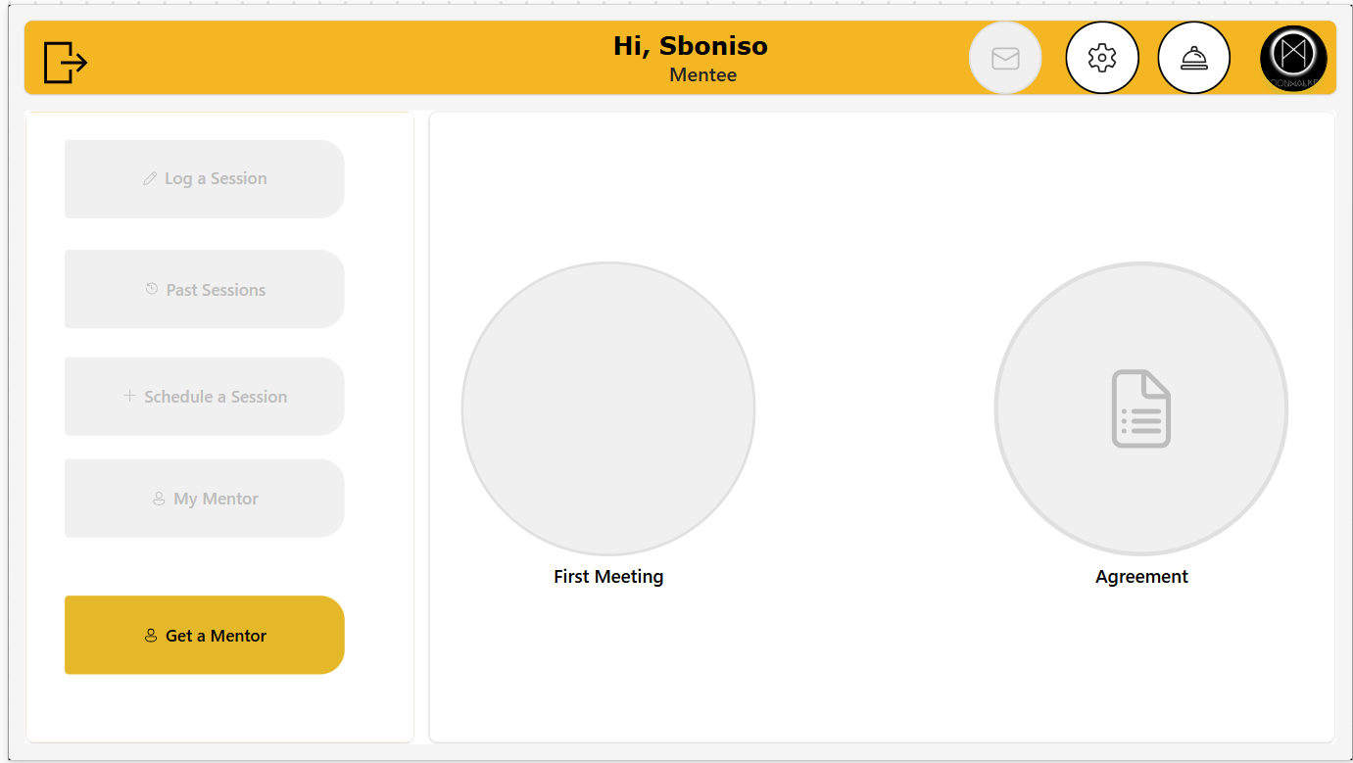
As a mentee you will have only the Get a mentor option enabled first which you must get a mentor before other options becomes available.
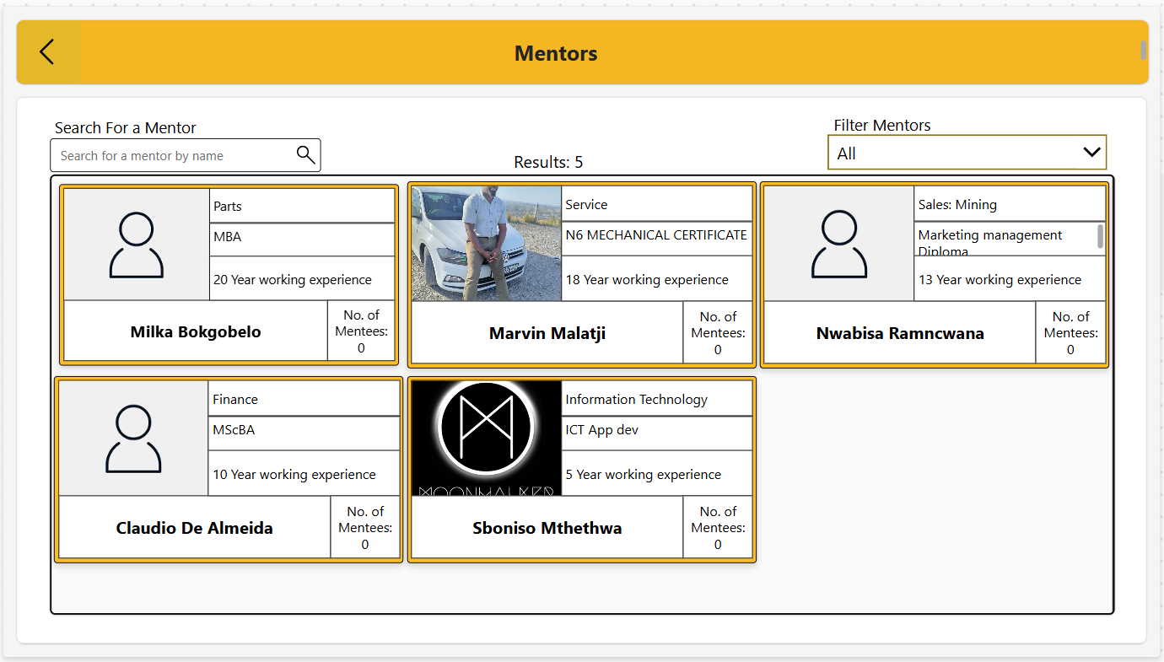
Click get mentor and select your mentor from the list as shown by photo. The mentors profile are shown profile(which they user to register including user profile pic from office) ,department, qualification, experience name number of mentees.
Once you click the mentor it displays their full profile detail they used to register including their LinkedIn profile link. If you are happy the press send request.
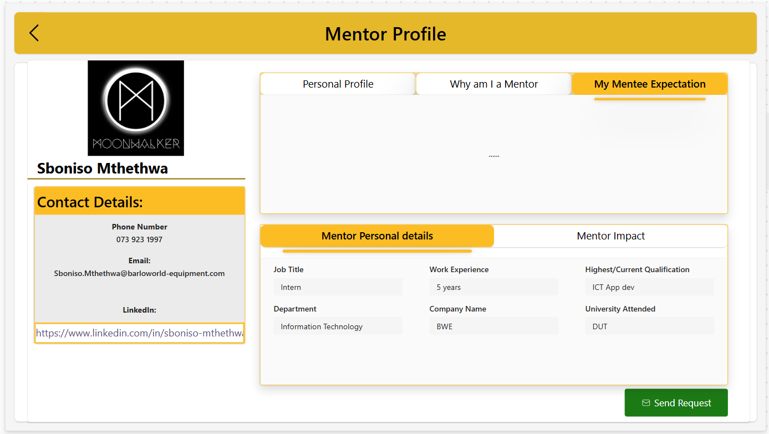
Then that will send the mentor an email that this user would like you to mentor them.
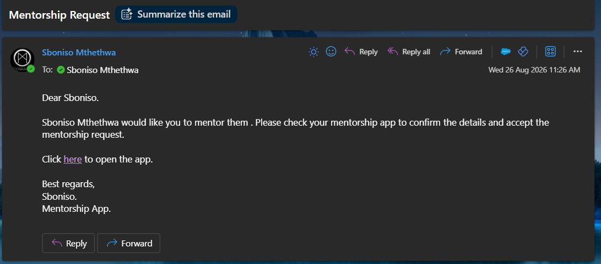

Mentor Dashboard
On the mentors dashboard they can see their points (get 100 for registering, 5 for logging in each day). You can see your Callender events ,button to see past session, button schedule a session, view a request made by a mentees to you. You can see your mentees, Next session with your mentee , Mentorship completion
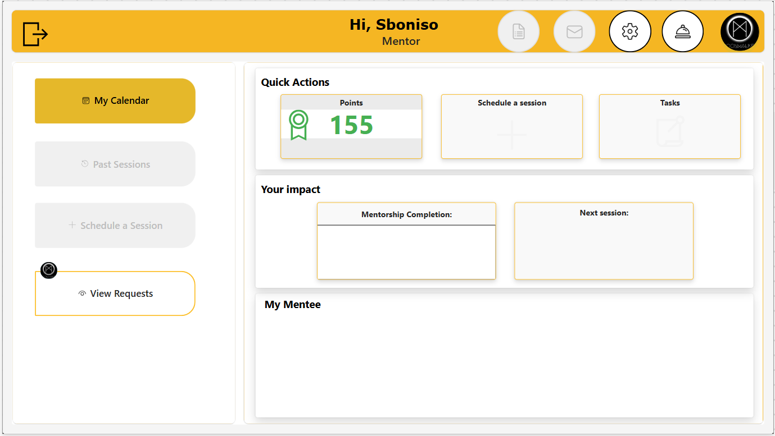

My Callender button
Loads your events.
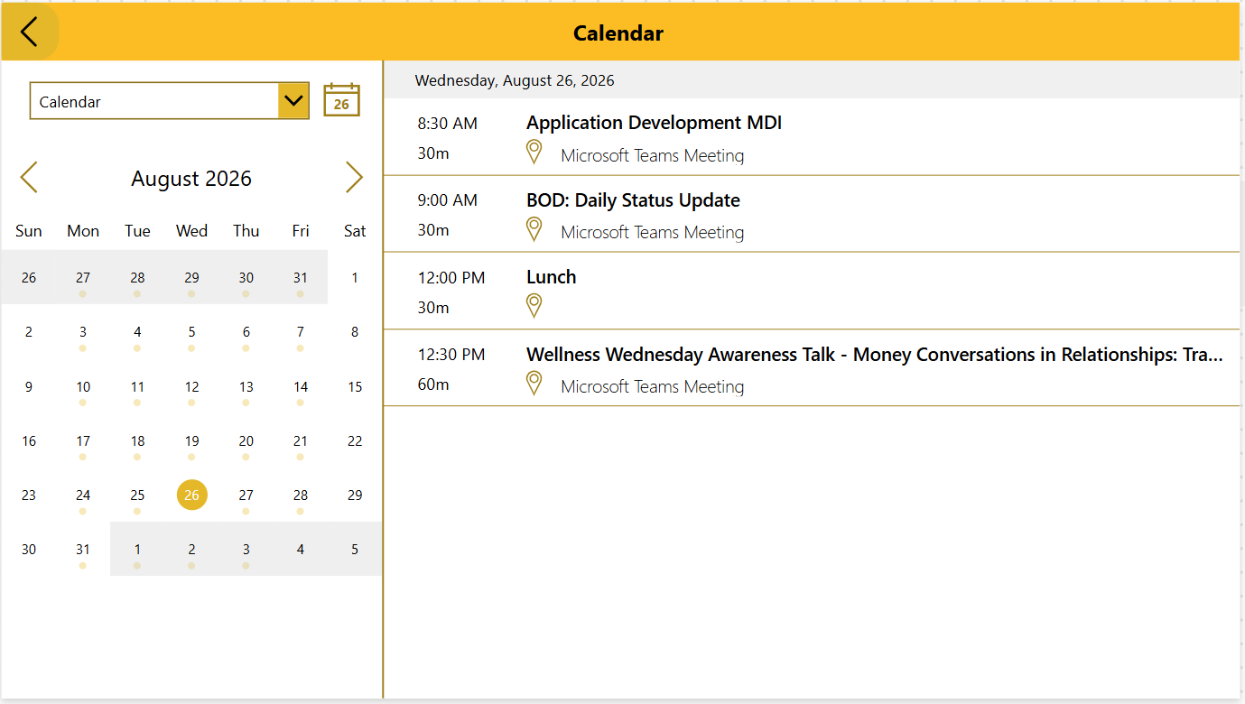
View requests
See all the requests you have as a mentor from mentees. You click on then shows you the mentee profile the you can reject request or accept.
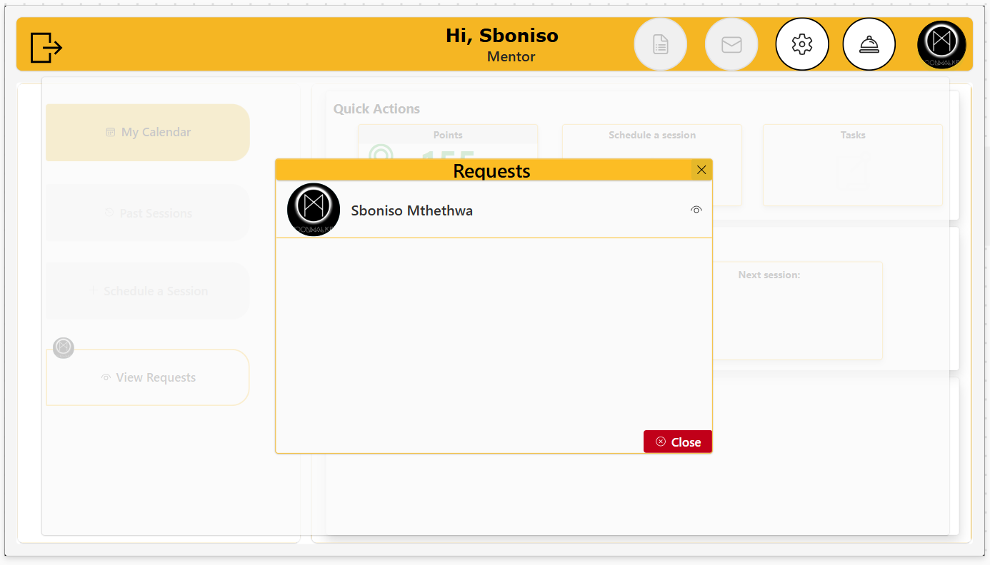
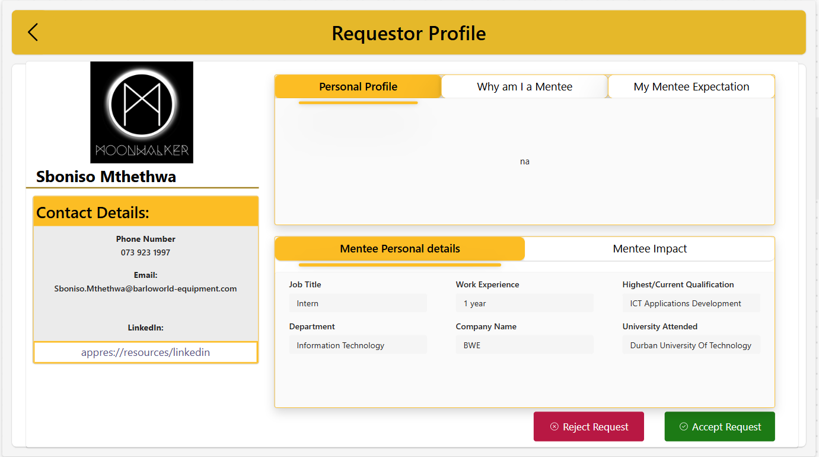
If you press accept then a suggest a session pop up where you can set up an ice breaker session including details like session title, summary of what the session is about , date, time and duration then click accept and send invitation
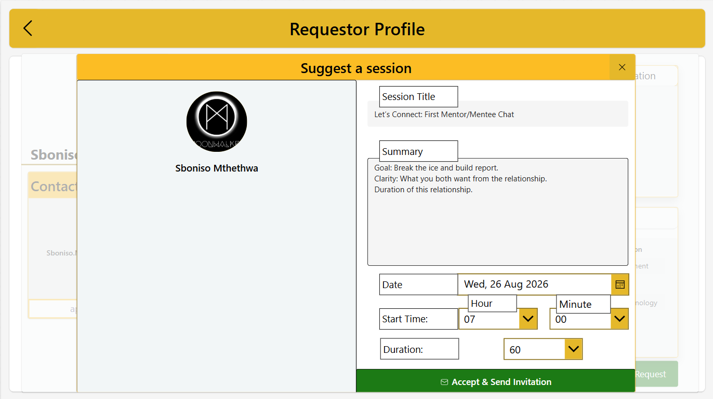
Once accepted that will send and email to the mentee to say that the mentor has accepted and has setup a session
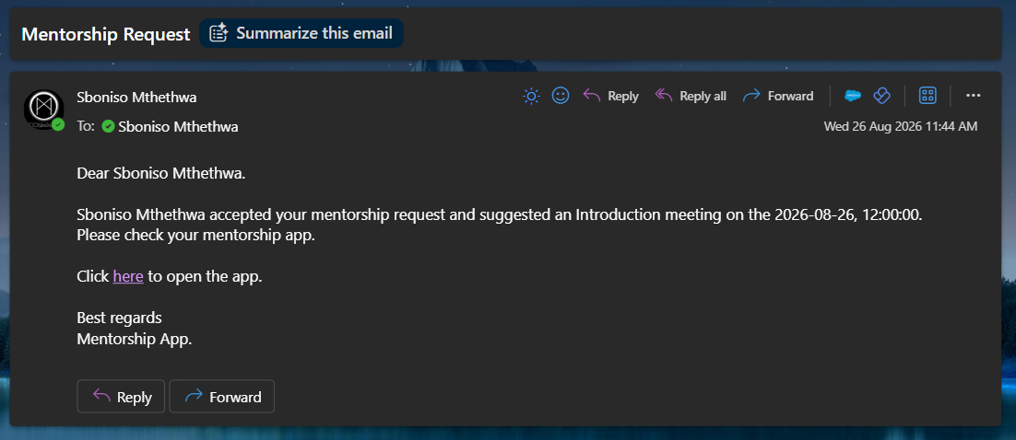

Back to mentee
Once you log in the app again you will see a notification to accept or reschedule the ice break session booked by the mentor
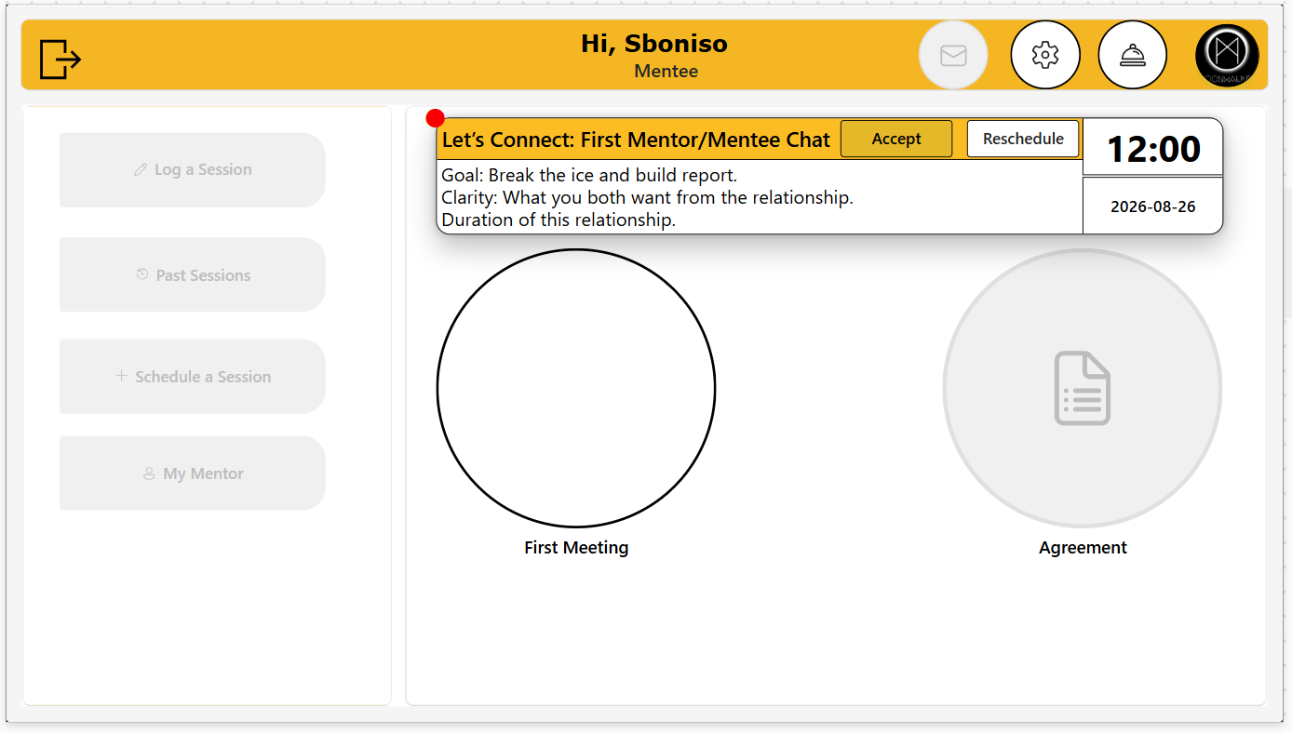

Once you accept it should setup a meeting on teams for the both of you and on the dashboard it should show you first meeting with your mentor
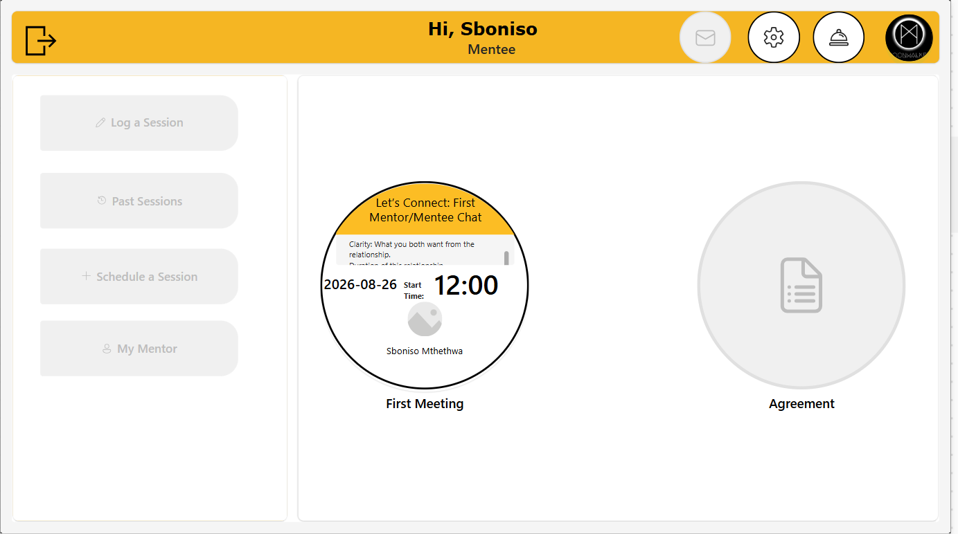
Then you should be able to schedule other sessions with your mentor and see past session also the mentor should be able schedule sessions with their mentee , assign task to them . and the mentee should be able to do and complete the task given by the mentor and submit them and the mentor should be able to grade those task. Another features is that you can use setting to set the maximum number of mentees max is 3 same time but can be agjusted also set you office availability and out of office
